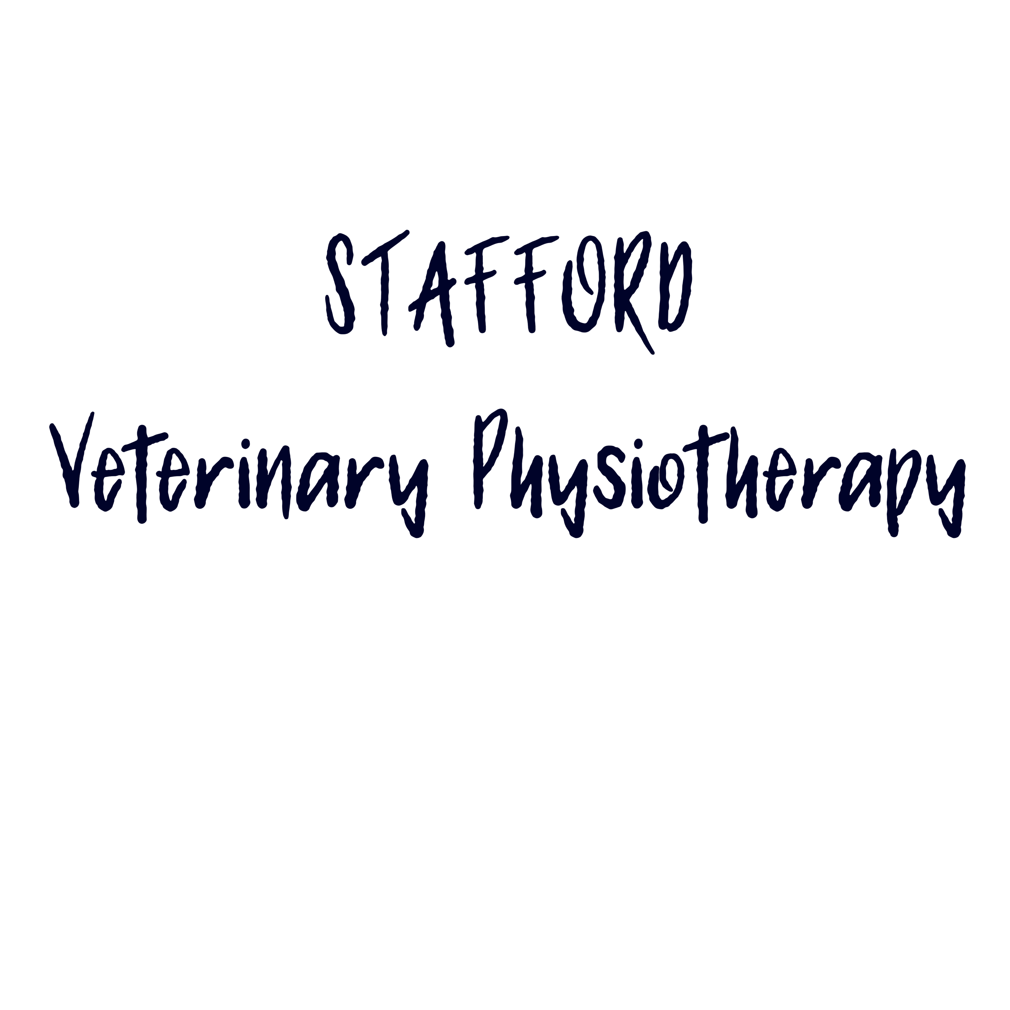
MAISIE FISCHER
BSc (Hons) Veterinary Physiotherapy
Mobile: 07463 163331
Email: staffordvetphysio@gmail.com
Website: www.staffordvetphysio.com
Address: 74 Wordsworth Avenue, Stafford, ST17 9UB

Please return to Maisie at Stafford Veterinary Physiotherapy via email or post.

VETERINARY REFERRAL FORM

Animal Details

Name |  |  |  |  |  |  | D.O.B. / Age
Breed
Sex |  |  |  | Neutered? (Y/N)
Insured? (Y/N) |  |  |  |  | Insurance Company
Client Details

Name
Address
Email address
Preferred contact number
Veterinary Surgery Details

Practice Name
Referring Veterinary Surgeon
Practice Address
Email address
Telephone number
Fax number

Alongside this form, can you please email any case notes to staffordvetphysio@gmail.com
Case History
Any advisories/requirements for physiotherapy:
Current Problem
Investigations and findings
Pre-existing conditions
Current medication

Declaration:
This patient is under my care and has received a full medical health check, and in my opinion is fit to undertake physiotherapy treatment. I give my authorisation for physiotherapy treatment to be carried out by Stafford Veterinary Physiotherapy.

Please be aware that if you are filling out the form electronically, you will have to print your name or initials instead of signing, please do this in the “signed” box.
Signed | Date
 | Print name
After the initial consultation a vet report will be sent back to you about any findings. Updates will be issued throughout treatment, and a final vet report will be sent on discharge. How would you like to receive these reports?

Email

Post
Fax

